LAB ASSIGNMENT 6

PROTOTYPE FACTORY DESIGN

SHRUTI MISHRA

21BCP110

DIV-2 G4

DIAGRAM:

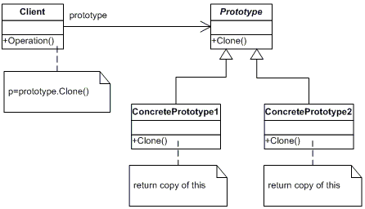

CODE:

* **Inside prototype package: -**
* Main.java //main file

package prototype;

public class Main{

    public static void main(String[] args) throws CloneNotSupportedException {

        InstrumentShop obj1 = new InstrumentShop();

        obj1.setShopname("MusicGaze Instruments");

        obj1.LoadData();

        InstrumentShop obj2 = obj1.clone();

        obj2.getInstrument().remove(1);

        obj2.setShopname("Saraswati Instruments");

        System.out.println(obj1);

        System.out.println(obj2);

    }

}

* InstrumentItem.java

package prototype;

public class InstrumentItem {

    private int Iid;

    private String Iname;

    //for Instrument-ID

    public int getIid() {

        return Iid;

    }

    public void setIid(int Iid) {

        this.Iid = Iid;

    }

    //for Instrument-Name

    public String getIname() {

        return Iname;

    }

    public void setIname(String iname) {

        Iname = iname;

    }

  @Override

    public String toString() {

        return "Instrument [Iid=" + Iid + ", Iname=" + Iname + "]";

    }

}

* InstrumentShop.java

package prototype;

import java.util.ArrayList;

import java.util.List;

public class InstrumentShop {

    private String shopname;

    List < InstrumentItem > items = new ArrayList<>();

    //for Shopname

    public String getShopname() {

        return shopname;

    }

    public void setShopname(String shopname) {

        this.shopname = shopname;

    }

    //for Instrument

    public List < InstrumentItem > getInstrument() {

        return items;

    }

    public void setInstrument(List < InstrumentItem > items) {

        this.items = items;

    }

    public void LoadData() {

        for (int i = 1; i <= 5; i++) {

            InstrumentItem Iobj = new InstrumentItem();

            Iobj.setIid(i);

            Iobj.setIname("Instrument" + i);

            getInstrument().add(Iobj);

        }

    }

    @Override

    public String toString() {

        return "InstrumentShop [shopname=" + shopname + ", instrument=" + items + "]";

    }

    @Override

    protected InstrumentShop clone() throws CloneNotSupportedException {

        //code to achieve deep cloning instead of shallow cloning

        InstrumentShop ishop = new InstrumentShop();

        for (InstrumentItem Iobj: this.getInstrument()) {

            ishop.getInstrument().add(Iobj);

        }

        return ishop;

    }

}

OUTPUT:

